**Project Design Phase-II**

**Data Flow Diagram & User Stories**

|  |  |
| --- | --- |
| Date | 03 October 2022 |
| Team ID | PNT2022TMID21704 |
| Project Name | Classification of Arrhythmia by Using Deep Learning with 2-D ECG Spectral Image Representation |
| Maximum Marks | 4 Marks |

**Data Flow Diagrams:**

A Data Flow Diagram (DFD) is a traditional visual representation of the information flows within a system. A neat and clear DFD can depict the right amount of the system requirement graphically. It shows how data enters and leaves the system, what changes the information, and where data is stored.

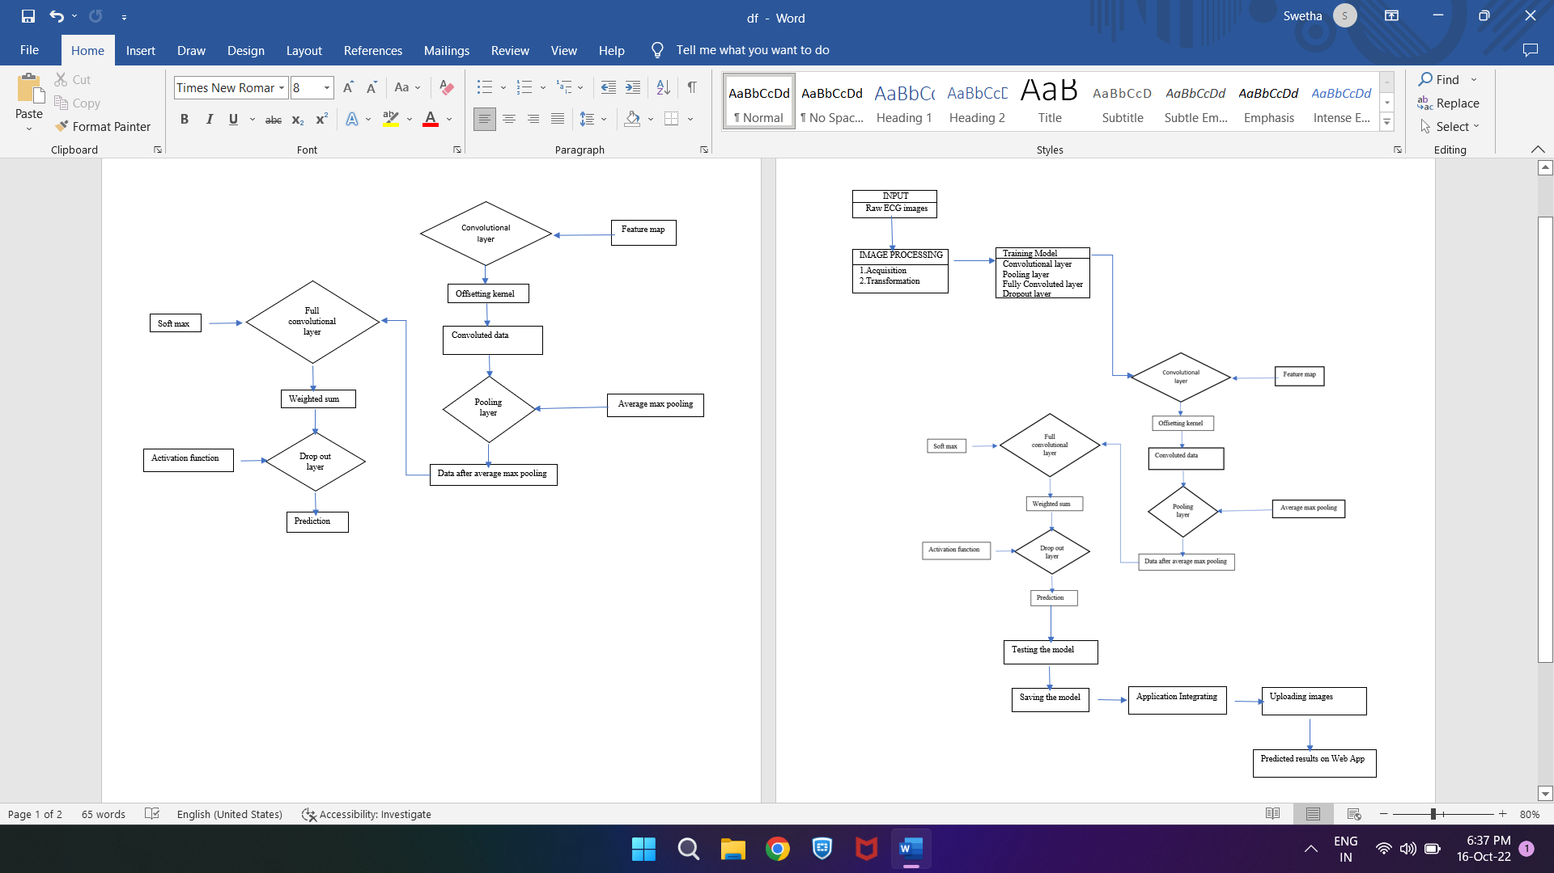

**User Stories**

Use the below template to list all the user stories for the product.

| **User Type** | **Functional Requirement (Epic)** | **User Story Number** | **User Story / Task** | **Acceptance criteria** | **Priority** | **Release** |
| --- | --- | --- | --- | --- | --- | --- |
| Customer (Web user) | Registration | USN-1 | As a web user, I can register for the application by entering my email, password, and confirming my password. | I can access my account / dashboard | High | Sprint-1 |
|  |  | USN-2 | As a web user, I will receive confirmation email once I have registered for the application | I can receive confirmation email & click confirm | High | Sprint-1 |
|  |  | USN-3 | As a web user, I can register for the application through Facebook | I can register & access the dashboard with Facebook Login | Low | Sprint-2 |
|  |  | USN-4 | As a web user, I can register for the application through Gmail | I can register & access the dashboard with Gmail | Medium | Sprint-1 |
|  | Login | USN-5 | As a web user, I can log into the application by entering email & password | I can access my account | High | Sprint-1 |
|  | Dashboard | USN-6 | As a web user, I can view the picture on the webpage once I uploaded it. | I get and “Upload Successful” pop-up | Medium | Sprint-1 |
|  |  | USN-7 | As a web user,I can view the results for the image I uploaded. | Result is displayed. | High | Sprint-1 |
| Customer Care Executive | Login | USN-1 | As a Customer Care Executive, I can login with my credentials. | I can access my account | High | Sprint-1 |
|  | Dashboard | USN-2 | As a Customer Care Executive, I can see all the information, I can view the picture on the webpage once I uploaded it | I get and “Upload Successful” pop-up | High | Sprint-1 |
|  | Responsiblities | USN-3 | As a Customer Care Executive, I am able to resolve the customers’ complaints. | Manage and resolve complaints | High | Sprint-1 |
| Administrator | Login | USN-1 | As an administartor, I can login with my credentials. | I can access my account/dashboard | High | Sprint-1 |
|  | Dashboard | USN-2 | As an administartor, I can see all the information, I can view the picture on the webpage once I uploaded it. | I can see all the information in the dashboard. | Low | Sprint-2 |
|  | Responsibilities | USN-3 | As an administrator, I can implement security measures and review web content | I can implement security measures. | High | Sprint-1 |